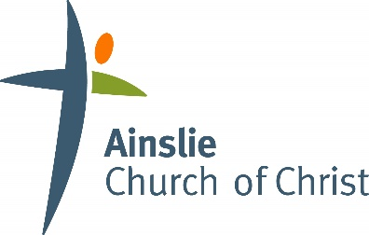

Safe Church Team Role Description
Adopted by Ainslie Church of Christ on 7 December 2020

A person appointed as a Safe Church Team Member should be a mature Christian who has been recruited according to the Procedure for Staff and Volunteers, have a current WWCC / WWVP clearance and have attended a Creating Safe Spaces workshop in the last 3 years. Close and direct liaison with the Senior Pastor / Senior leader and an ability to maintain confidentiality is essential.

The responsibilities of the Safe Church Team include:
- to provide oversight of the church’s Safe Church program, including Safe Church Policy and procedures.
- to provide oversight of the management of Safe Church/Child Protection concerns/reports.

Specific Roles:
1. Oversight of Safe Church Policy and Procedures.
- Preparing Safe Church Policy and Procedures for the church to comply with legal responsibilities;
- Implementing Safe Church Policy and procedures;
- Promoting awareness of and adherence to Safe Church Policy and procedures (including ensuring that staff and volunteers have completed National Police Checks, WWCC/WWVP clearances and Creating Safe Spaces training);
- Maintaining records related to Safe Church Policy and procedures;
- Preparing regular reports for Deacons/Elders/church leadership meetings;
- Reviewing Safe Church Policy and procedures annually or more often if required due to changing legislation;
- Receiving feedback from church leaders, children, families and communities regarding Safe Church Policy and procedures; and
- Overseeing the completion of the ‘Safe Church Health Check’ every 3 years.

2. Management of Safe Church/Child Protection Concerns and Incidents.
- Receiving reports of child protection concerns from church staff, volunteers, ministry leaders and/or church members;
- Providing support in following the procedure for responding to child protection concerns and incidents;
- Contacting the Fresh Hope Safe Ministry Practices Leader to discuss action plan/appropriate action;
- Making any reporting calls (to Police, Government agencies) as required;
- Ensuring reporting in line with relevant Reportable Conduct Legislation;
- Ensuring child protection concerns and subsequent responses have been appropriately documented;
- Ensuring adequate follow-up and pastoral care of all persons involved in a child protection concern/incident;
- Assisting with legal, procedural and risk management issues related to a child protection concern/incident;
- Keeping records, filing complaints and reports of investigations in a secure file, in accordance with the Safe Church Policy.

