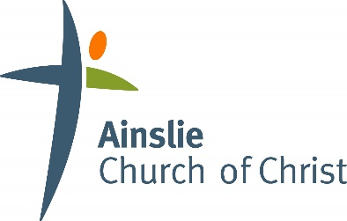

Ministry Information Form

Church name: | AINSLIE CHURCH OF CHRIST
Program name:

GENERAL INFO
Participants Name: |  |  | DOB:
Parent/guardian name(s):
Email:
Phone:
Dietary issues. Is there anything your child cannot eat or drink? |  | ☐ Yes (please indicate below) |  |  | ☐ No
Medical conditions: Please list any medical conditions or allergies, and any medication or special care they require. If your child is anaphylactic to any substance please provide information regarding EpiPen and management plan.
Transport authority: If I am unable to collect my child at the finishing time they may be transported home from the program with the following people:

IN CASE OF EMERGENCY
Emergency Contact 1:
Name:
Relationship to child:
Mobile phone:
Emergency Contact 2:
Name:
Relationship to child:
Mobile phone:

Please acknowledge the following:
☐ | I authorise the leader in charge to arrange for my child to receive such first aid and medical treatment as a trained first aid person may deem necessary
☐ | I authorise the use of calling an ambulance in an emergency
☐ | I accept responsibility for payment of all expenses associated with such treatment

Please read the follow statement and tick the boxes from which you wish to preclude your children:
☐ | I DO NOT give permission for my child to participate in activities outside of the normal meeting complex except where they are within reasonable walking distance
☐ | I DO NOT give permission for my child to be transported in private cars arranged by the leaders of the group
☐ | I DO NOT permit photos taken of my child to be displayed in church publications, e.g. website, newsletters, brochures, etc.

Name of Parent/Guardian:
Parent/Guardian Signature |  | Date

