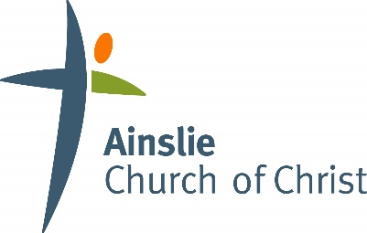

Volunteer Screening Interview

This form is a suggested starting point for interviewing a potential ministry program team member. Before starting the interview, inform the applicant that their answers may be disclosed to appropriate leaders in the church. Interviews should be conducted by a minimum of two people, ensuring that there is no actual or perceived conflict of interest for those conducting the interview.

- Open in prayer
- Can you describe more fully the reasons you desire to be involved with this ministry?
- Can you describe a positive experience in your past ministry?
- Can you describe a negative experience in your past ministry?
- Do you consider yourself a positive role model? Why/not?
- Is there any other information relating to your suitability for this ministry?
- [add in ministry-specific questions]

- Read through the Code of Conduct together.
- Read through and discuss any YES responses to the screening check questionnaire.

Team Commitment
- In becoming a Volunteer Leader, I agree to adhere to the code of conduct and to attend team meetings and in-service training.
- I am willing to make a commitment to team leadership.
- I commit to this team for |  | months at the end of which I will renew my commitment
to the team or alternatively give my team leader notice that I do not wish to continue in this role.

Applicant: |  | Signature:

Interviewer 1: |  |  | Signature:
Interviewer 2: |  |  | Signature:
Interviewer 3: |  |  | Signature:
Interviewer 4: |  |  | Signature:
Date of interview:

